# 

# 

# 

# Experiment #9: Frequency Response

Christopher Badolato

Yajaira Varillas Perez

EEL3123C-0013

4/3/2019

## 

## 

## 

## 

## 

## 

## Objectives

* To study the transfer function of a circuit.
* To use the transfer function to find the specified frequency specified in the different cases.

## Equipment

* Breadboard
* Function generator
* Oscilloscope
* Digital multimeter (DMM)

Circuits (taken directly from lab manual)

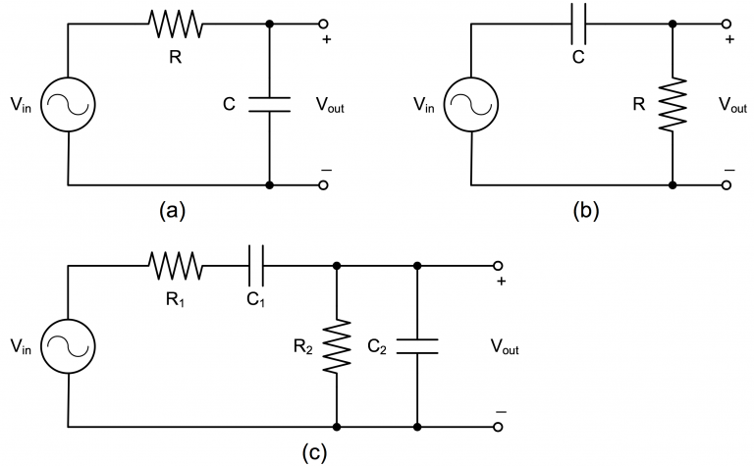

Simulations

|  |
| --- |
| For this simulation, we accidentally used the input voltage of 10V but as we can see from the graph below the trend of the frequency response is the same.  For each of the simulations, we have created a Frequency vs. Voltage Magnitude line graph as well as a Frequency vs. Phase angle.  Some of our measurements taken from the simulation are the negative phase difference but if we invert the graph we can see that it represents the same phase difference and trend of the graph.  **Each graph corresponds to the data above it.** |

**Circuit A**

|  |  |
| --- | --- |
| **Frequency (Hz)** | **Voltage (V)** |
| 100 | 9.980319 |
| 501.1872 | 9.538245 |
| 1000 | 8.46733 |
| 5011.872 | 3.026619 |
| 10000 | 1.571767 |
| 19952.62 | 0.795139 |
| 30199.52 | 0.526281 |
| 50118.72 | 0.317396 |
| 75857.76 | 0.209761 |
| 100000 | 0.159135 |

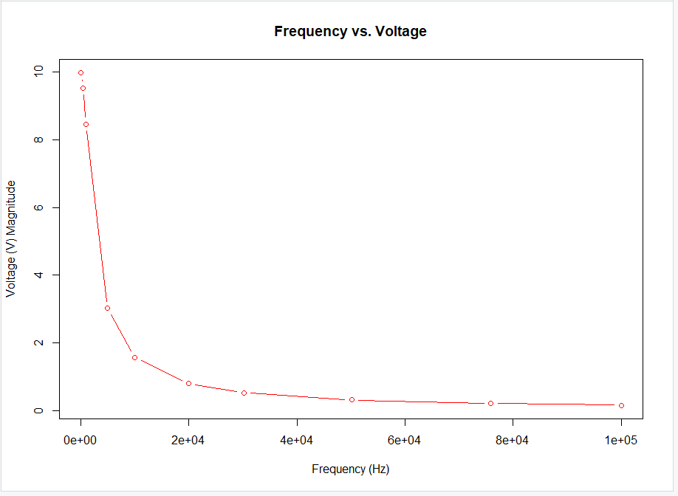

**Circuit A**

|  |  |
| --- | --- |
| **Frequency (Hz)** | **Phase angle(°)** |
| 100 | -3.59527 |
| 501.1872 | -17.4795 |
| 1000 | -32.1419 |
| 5011.872 | -72.3824 |
| 10000 | -80.9569 |
| 19952.62 | -85.4394 |
| 30199.52 | -86.983 |
| 50118.72 | -88.1812 |
| 75857.76 | -88.7981 |
| 100000 | -89.0882 |

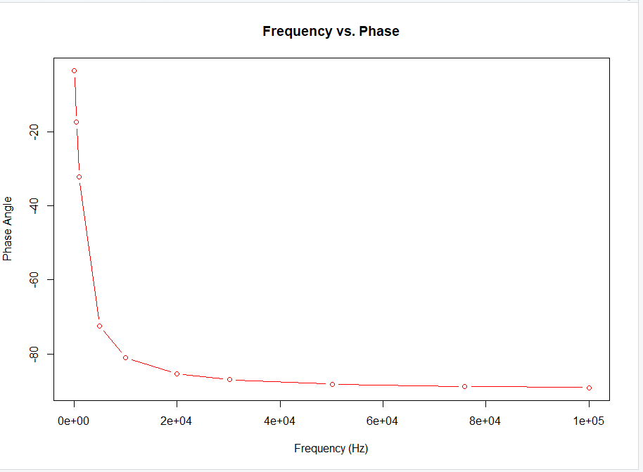

**Circuit B**

|  |  |
| --- | --- |
| **Frequency (Hz)** | **Voltage (V)** |
| 100 | 0.627082 |
| 501.1872 | 3.003643 |
| 1000 | 5.32018 |
| 5011.872 | 9.53098 |
| 10000 | 9.875705 |
| 19952.62 | 9.968338 |
| 31622.78 | 9.987359 |
| 50118.72 | 9.987359 |
| 75857.76 | 9.997993 |
| 100000 | 9.998734 |

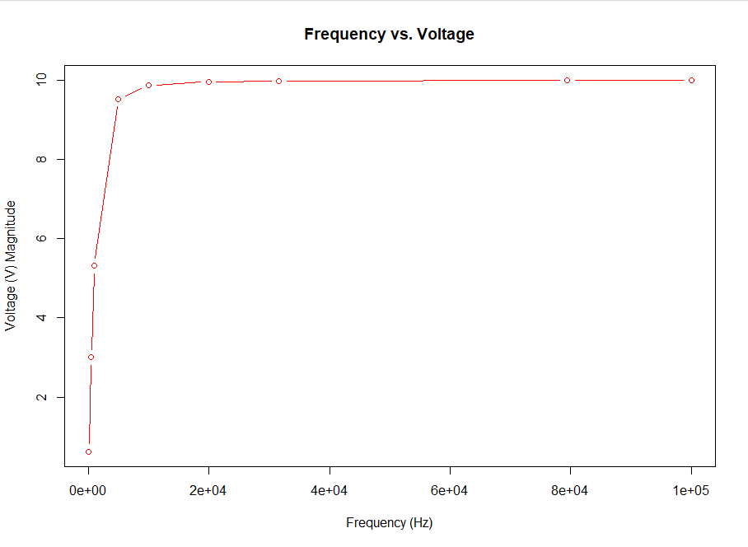

**Circuit B**

|  |  |
| --- | --- |
| **Frequency (Hz)** | **Phase angle(°)** |
| 100 | 86.40473 |
| 501.1872 | 72.5205 |
| 1000 | 57.85809 |
| 5011.872 | 17.61755 |
| 10000 | 9.043061 |
| 19952.62 | 4.560623 |
| 31622.78 | 2.88122 |
| 50118.72 | 1.81885 |
| 79432.81 | 1.147849 |
| 100000 | 0.911814 |

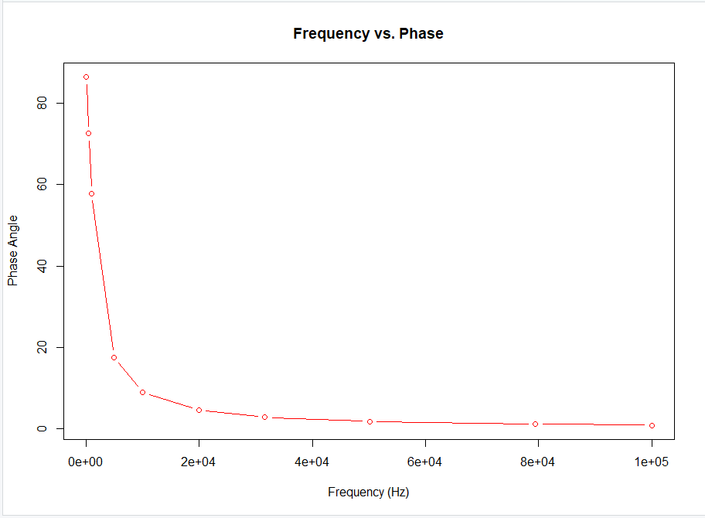

**Circuit C**

|  |  |
| --- | --- |
| **Frequency (Hz)** | **Voltage (V)** |
| 100 | 0.625065 |
| 501.1872 | 2.80297 |
| 1000 | 4.394652 |
| 5011.872 | 6.002418 |
| 10000 | 5.983912 |
| 19952.62 | 5.640779 |
| 30199.52 | 5.146519 |
| 50118.72 | 4.168682 |
| 75857.76 | 3.199572 |
| 100000 | 2.579901 |

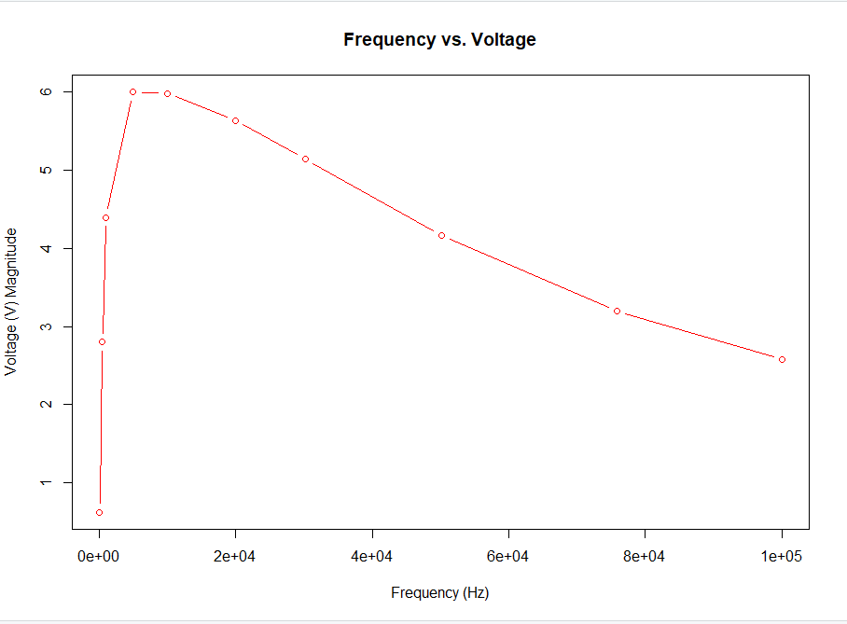

**Circuit C**

|  |  |
| --- | --- |
| **Frequency (Hz)** | **Phase angle(°)** |
| 100 | 84.04422 |
| 501.1872 | 62.27081 |
| 1000 | 43.15448 |
| 5011.872 | 4.862196 |
| 10000 | -6.62162 |
| 19952.62 | -20.5495 |
| 30199.52 | -31.3151 |
| 50118.72 | -46.2113 |
| 75857.76 | -57.9182 |
| 100000 | -64.6426 |

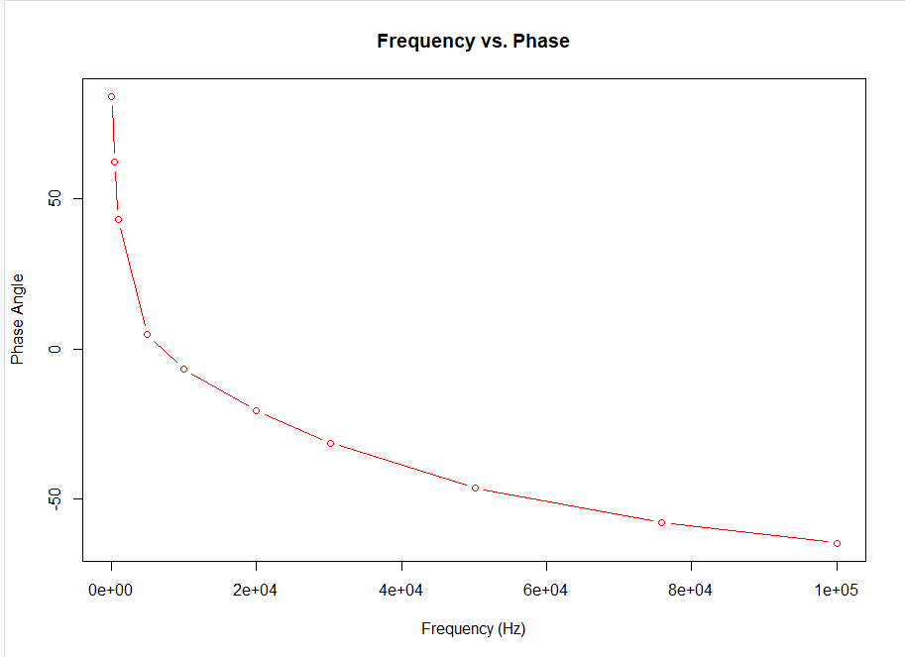

Experiment

|  |
| --- |
| 1. On a breadboard build circuit (a) found on page 3 of this report. Connect channel 1 to input & channel 2 to output so both are displayed on the oscilloscope. 2. Input voltage:   Vary frequency from 100 Hz - 100 kHz  Plot the Voltage v.s Frequency Curve & Phase v.s Frequency curve on either a linear or log scale - using ten frequency values  Determine the amplitude & phase from the oscilloscope   1. Compare from preparation and/or simulation. What kind of filter is it? 2. Repeat steps 1-3 for circuit (b) & (c) found on page 3 of this report. |
| **Each graph corresponds to the data above it.** |

|  |
| --- |
| **Circuit A** |

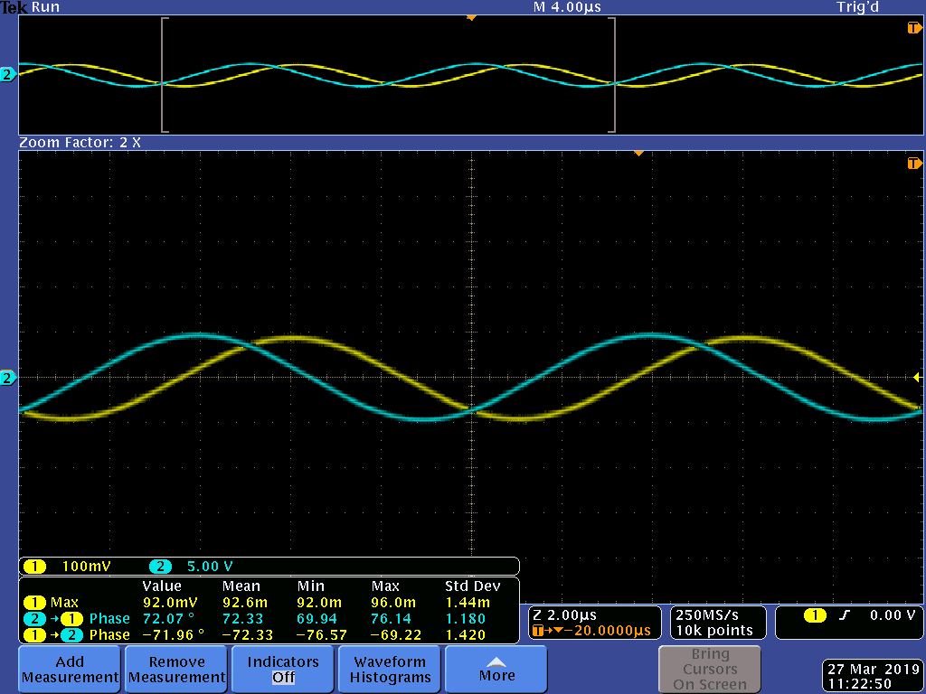

|  |  |
| --- | --- |
| **Frequency (Hz)** | **Voltage (V)** |
| 100 | 5.20 |
| 500 | 4.80 |
| 1000 | 4.08 |
| 5000 | 1.44 |
| 10000 | .880 |
| 20000 | .420 |
| 30000 | .300 |
| 50000 | .172 |
| 75000 | .116 |
| 100000 | .096 |

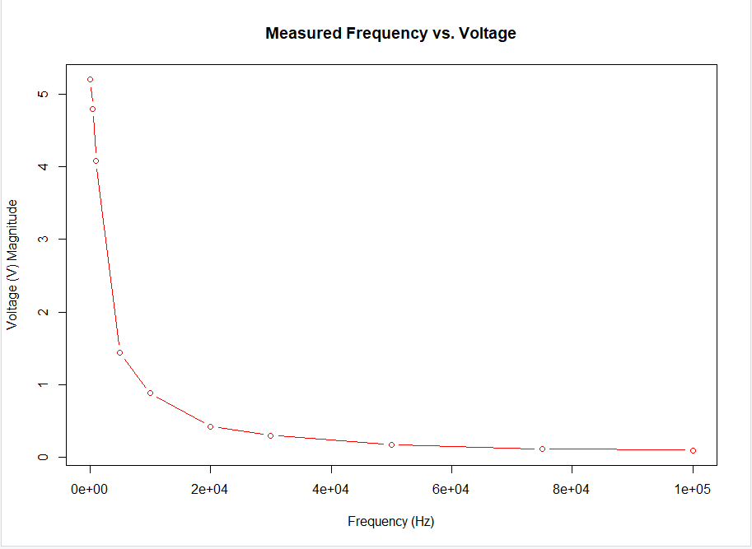

|  |
| --- |
| **Circuit A**  This graph demonstrates that this is a low pass filter. These results match the simulation and the preparation graph as well as the conclusion about the filter. |

|  |  |
| --- | --- |
| **Frequency (Hz)** | **Phase angle(°)** |
| 100 | 6.9 |
| 500 | 22.8 |
| 1000 | 36.6 |
| 5000 | 69.67 |
| 10000 | 76 |
| 20000 | 77 |
| 30000 | 77 |
| 50000 | 80 |
| 75000 | 81 |
| 100000 | 84 |

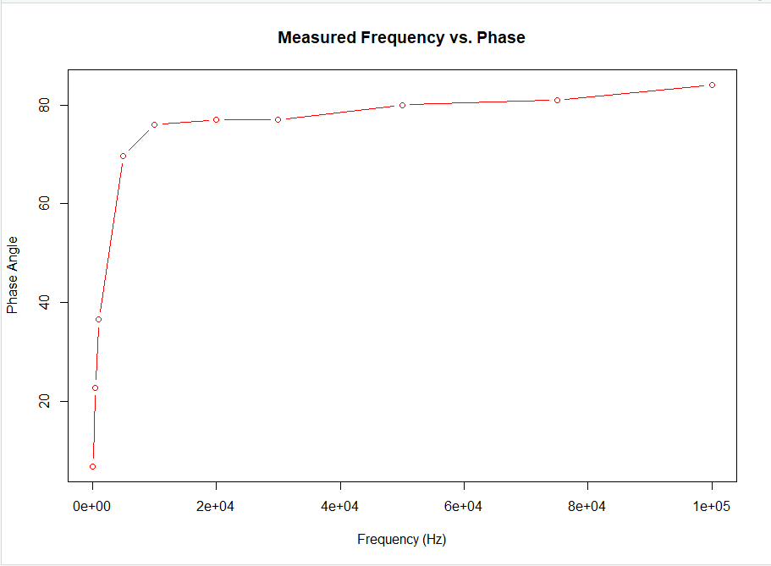

|  |
| --- |
| **Circuit B** |

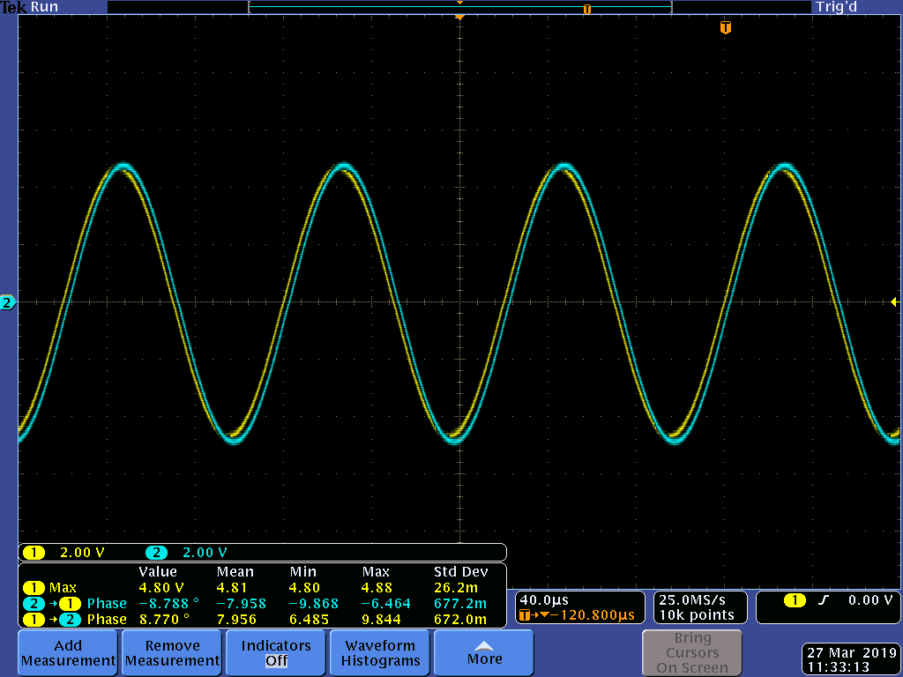

|  |  |
| --- | --- |
| **Frequency (Hz)** | **Voltage (V)** |
| 100 | 0.376 |
| 500 | 1.68 |
| 1000 | 2.80 |
| 5000 | 4.64 |
| 10000 | 4.80 |
| 20000 | 4.80 |
| 30000 | 5.00 |
| 50000 | 4.88 |
| 75000 | 4.88 |
| 100000 | 4.96 |

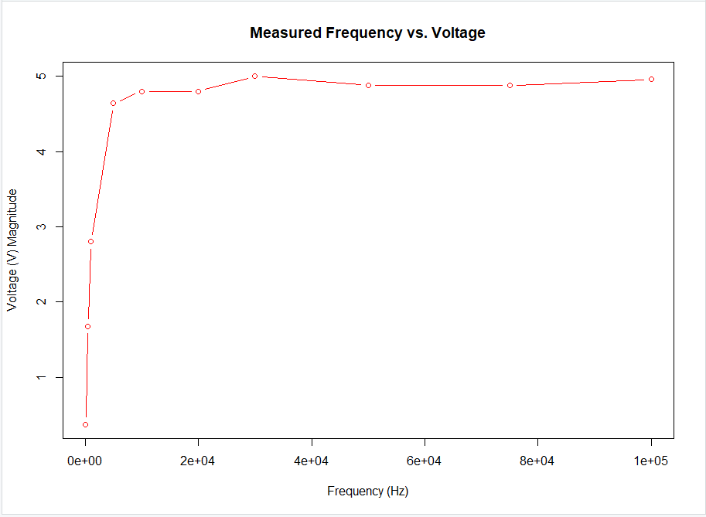

|  |
| --- |
| **Circuit B**  This graph demonstrates that this is a high pass filter. These results match the simulation and the preparation graph as well as the conclusion about the filter. |

|  |  |
| --- | --- |
| **Frequency (Hz)** | **Phase angle(°)** |
| 100 | -85 |
| 500 | -70.24 |
| 1000 | -53 |
| 5000 | -18 |
| 10000 | -8.22 |
| 20000 | -5.024 |
| 30000 | -6.3 |
| 50000 | -3.068 |
| 75000 | -2.156 |
| 100000 | -1.62 |

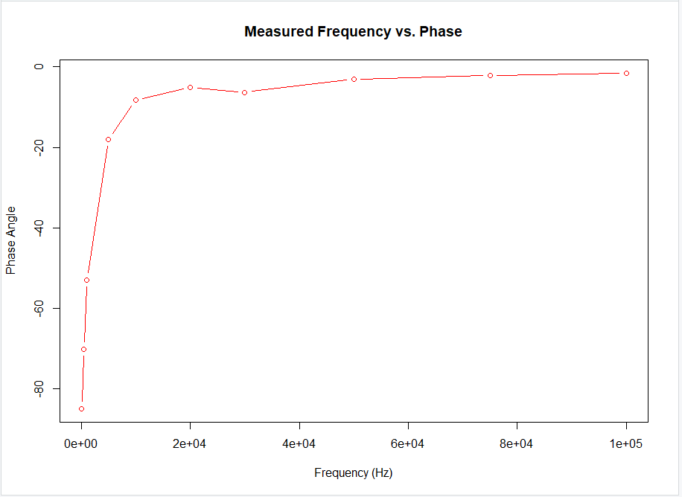

|  |
| --- |
| **Circuit C** |

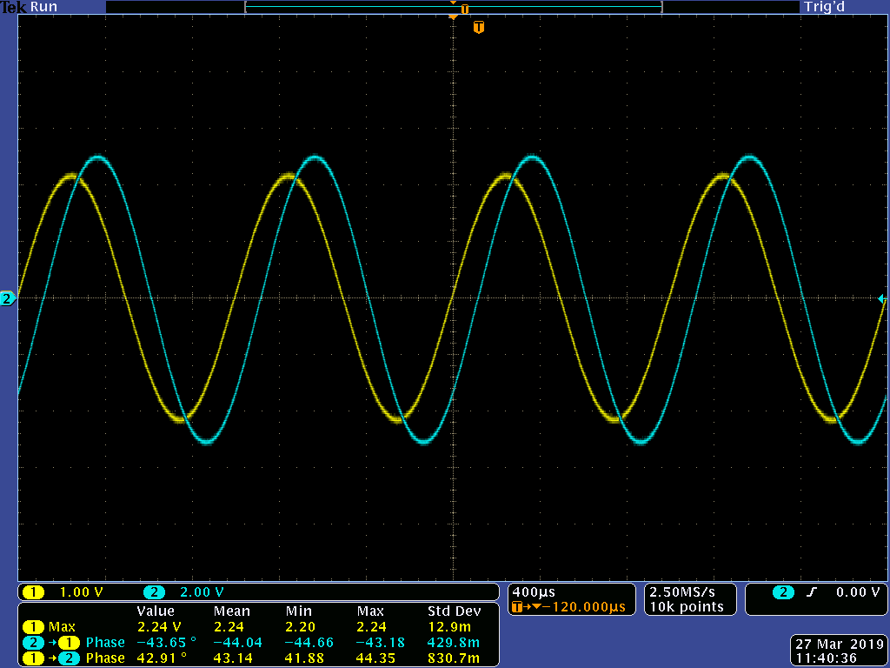

|  |  |
| --- | --- |
| **Frequency (Hz)** | **Voltage (V)** |
| 100 | 0.32 |
| 500 | 1.42 |
| 1000 | 2.24 |
| 5000 | 3 |
| 10000 | 3 |
| 20000 | 2.80 |
| 30000 | 2.56 |
| 50000 | 2.12 |
| 75000 | 1.64 |
| 100000 | 1.36 |

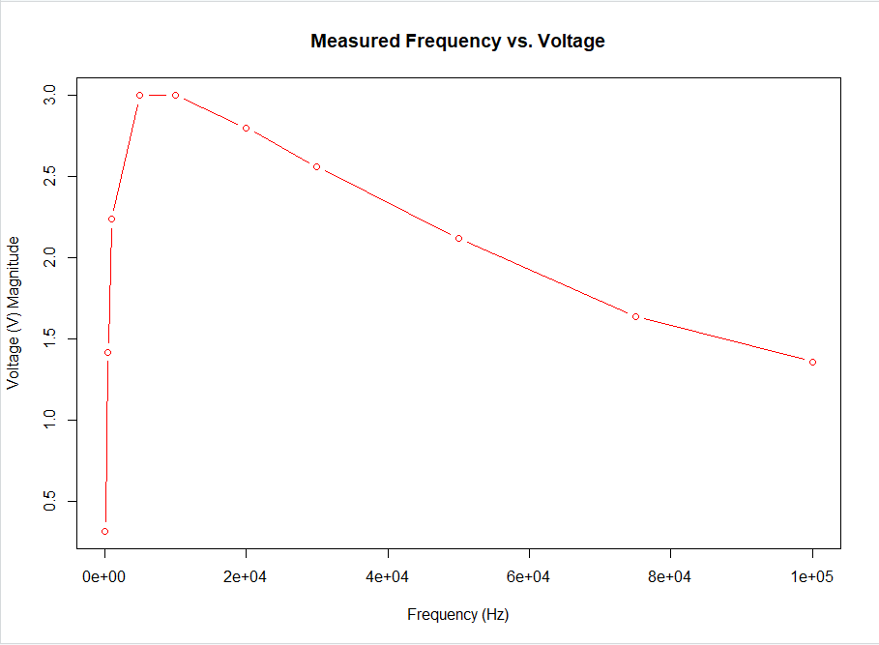

|  |
| --- |
| **Circuit C**  This graph and transfer function demonstrates that this is a band pass filter. These results match the simulation and the preparation graph as well as the conclusion about the filter. |

|  |  |
| --- | --- |
| **Frequency (Hz)** | **Phase angle(°)** |
| 100 | -83.96 |
| 500 | -61.92 |
| 1000 | -43.85 |
| 5000 | -5.31 |
| 10000 | 5.554 |
| 20000 | 20.15 |
| 30000 | 28.17 |
| 50000 | 41 |
| 75000 | 51.54 |
| 100000 | 59.54 |

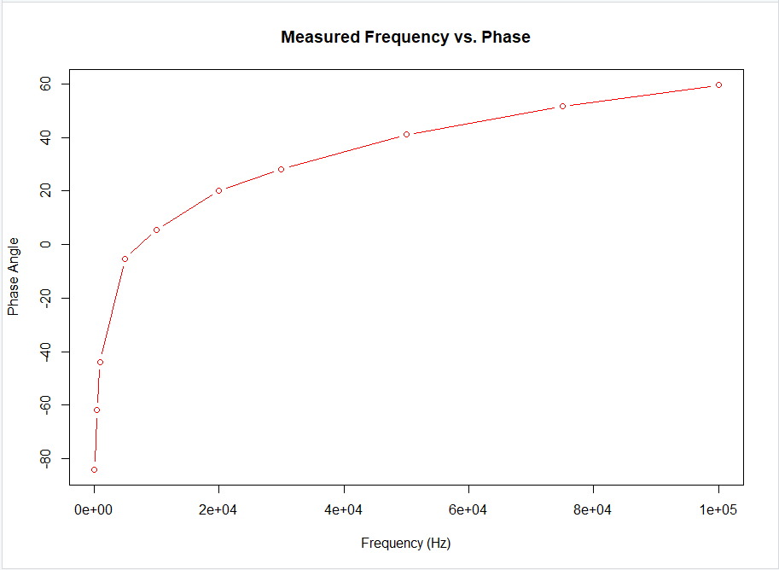

Conclusion

The purpose of this lab was to simulate and analyze circuits on the computer using MultiSim and using the physical breadboard to determine how different frequencies affect the overall shape of the graphs from the experiment. Based on the different ranges of frequencies, we have determined what kind of filters each circuit had demonstrated. The only small error that was made was the input voltage in the simulations part of the experiment.

Prelab

